Software Engineering Project:   Arrange summer camp schedules

# Description:

The purpose of our project is to help parents plan their children's summer camps. If you have school-age children at home, how to arrange the long summer break every year will be a headache. The purpose of this project is to help parents arrange their summer break plans in a better way, which can be managed more intuitively through charts and other means.

# Wireframes

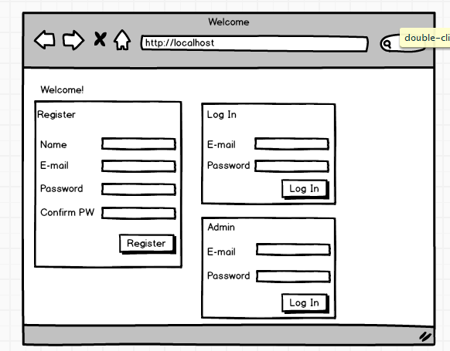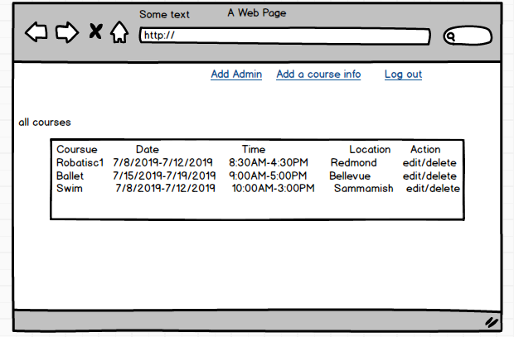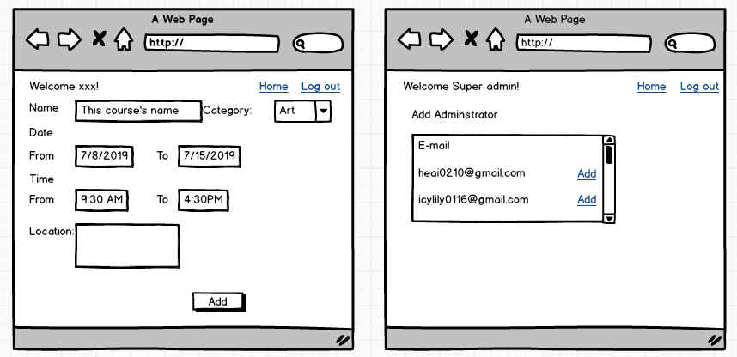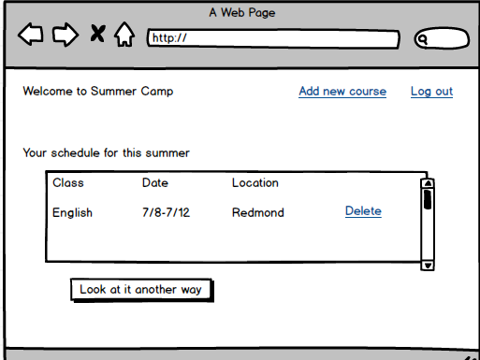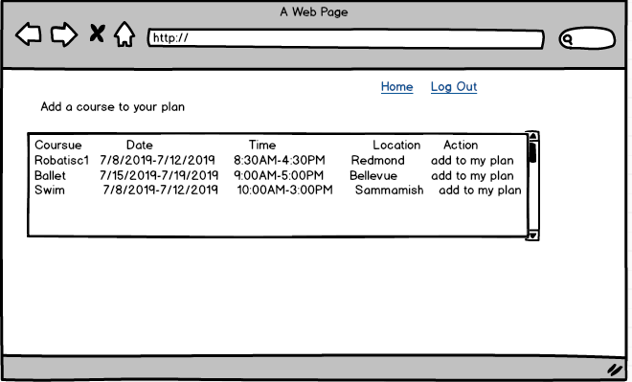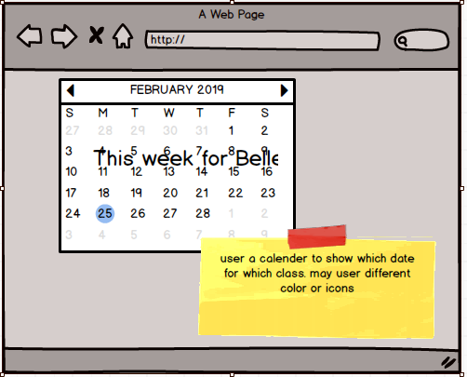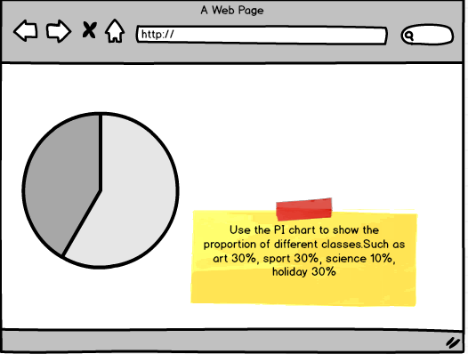

# Feature List

|  |  |  |  |  |  |  |
| --- | --- | --- | --- | --- | --- | --- |
| Model | | Feature | | | Owner | priority |
|  | Admin | 1.The super administrator is default and cannot be registered. | | | LILI MAN | P0 |
| 2. Super admin can change password | | | LILI MAN | P0 |
| 3.Super admin can add/edit/delete courses | | | LILI MAN | P0 |
| 4.Super admin can add/edit/delete normal admin | | | LILI MAN | P1 |
| 5.Normal admin can change password, add courses, can not delete courses, can not add another admin. | | | LILI MAN | P1 |
| 6.support import courses information from txt or exel | | |  | P2 |
| 7.get the courses information from external website and import it automatically | | |  | P3 |
| Users | 1.User can register and login into this system | | | AI HE | P0 |
| 2.Logined users can view all course records | | | AI HE | P0 |
| 3.logined user can create a plan | | | AI HE | P0 |
| 4.logined user can add/remove a course to their plan | | | AI HE | P0 |
| 5.logined user can add/remove multiple courses to their plan at one time . | | | LILI MAN | P1 |
| 6.logined user can add multiple pan for another kids | | | LILI MAN | P1 |
| 7.logined user can see other user’s plan and decide if they want to join this plan | | |  | P3 |
| 8.user chart or graph display the plan for whole summer, user 3rd API | | | LILI MAN | P1 |
| 9.save the plan to google or outlook calendar | | |  | P3 |
|  |  |  |  |  |  |  |

# Technical Considerations

* Python/Django
* HTML/JQuery/Bootstrap
* Fullcanlendar—3rd API
* 3rd api for report or other

# Work Distribution

Same as the owner of the feature list